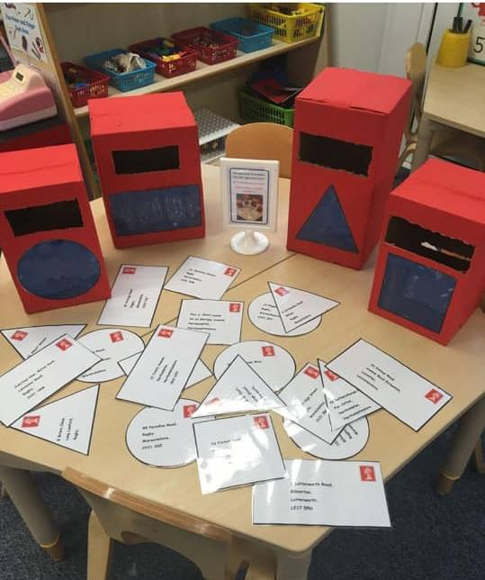
Postbox letter shape sorting
Please note, we did not develop the original idea of this, but have been inspired by a Pinterest pin


I’m a text box to enable you to input your own address
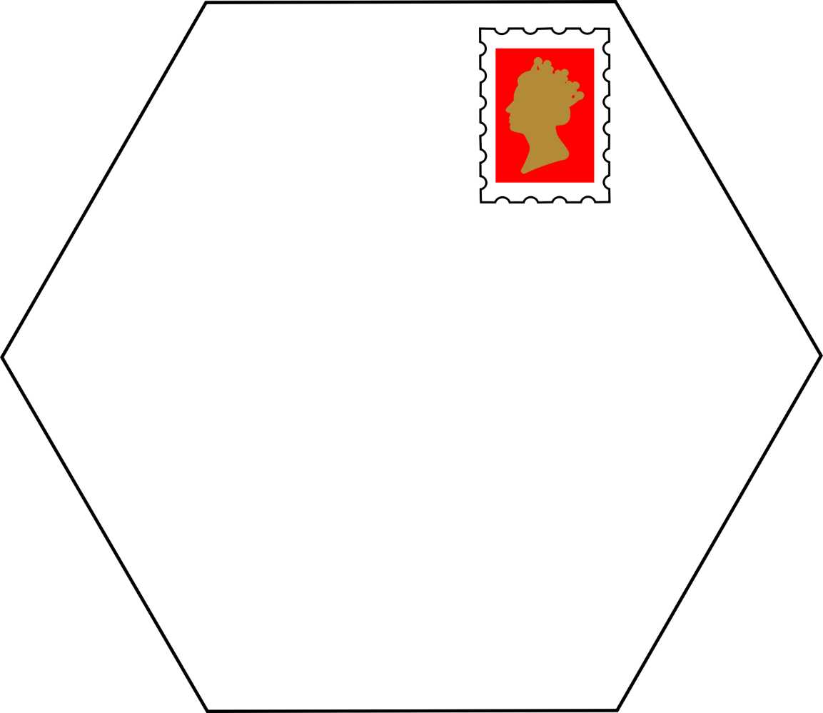
I’m a text box to enable you to input your own address

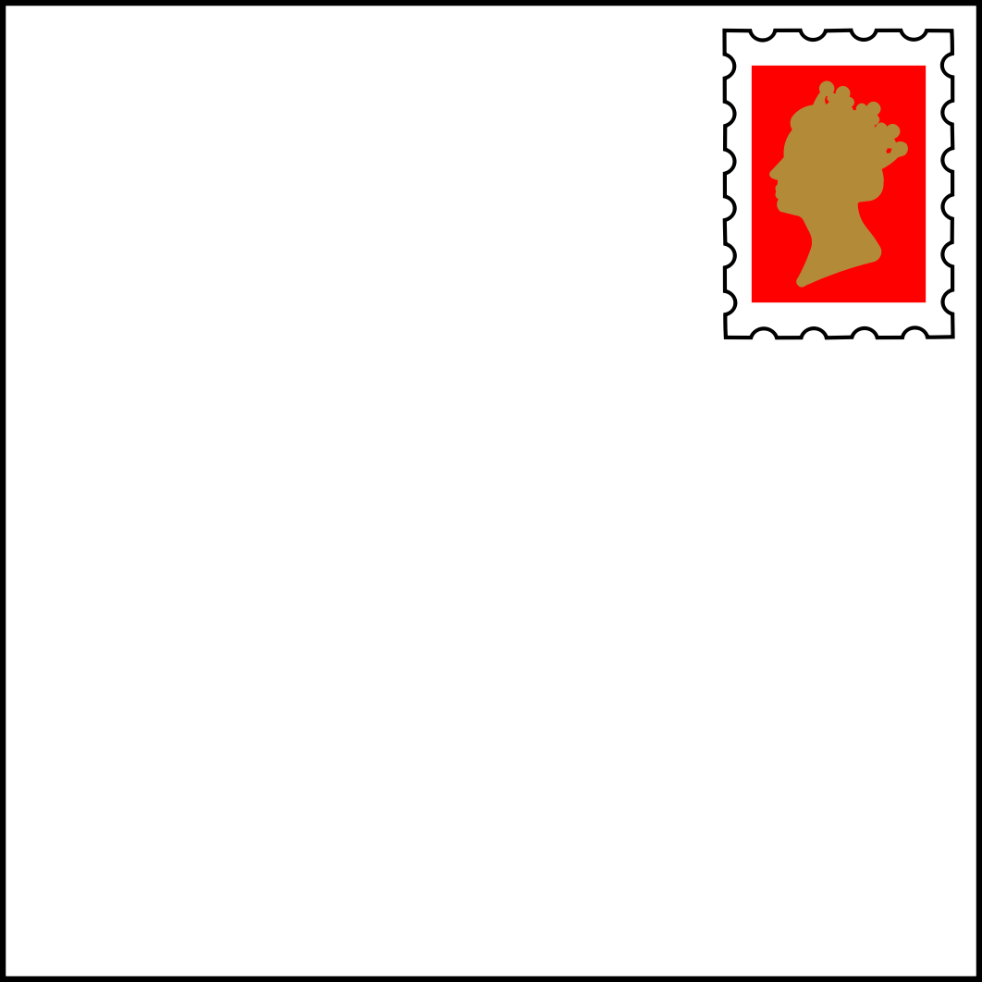
I’m a text box to enable you to input your own address
I’m a text box to enable you to input your own address
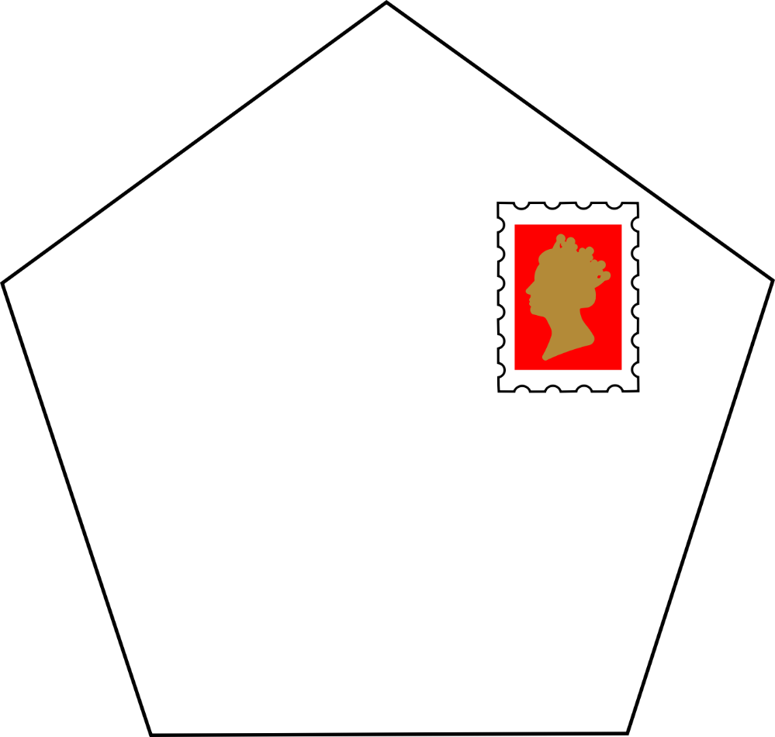
I’m a text box to enable you to input your own address

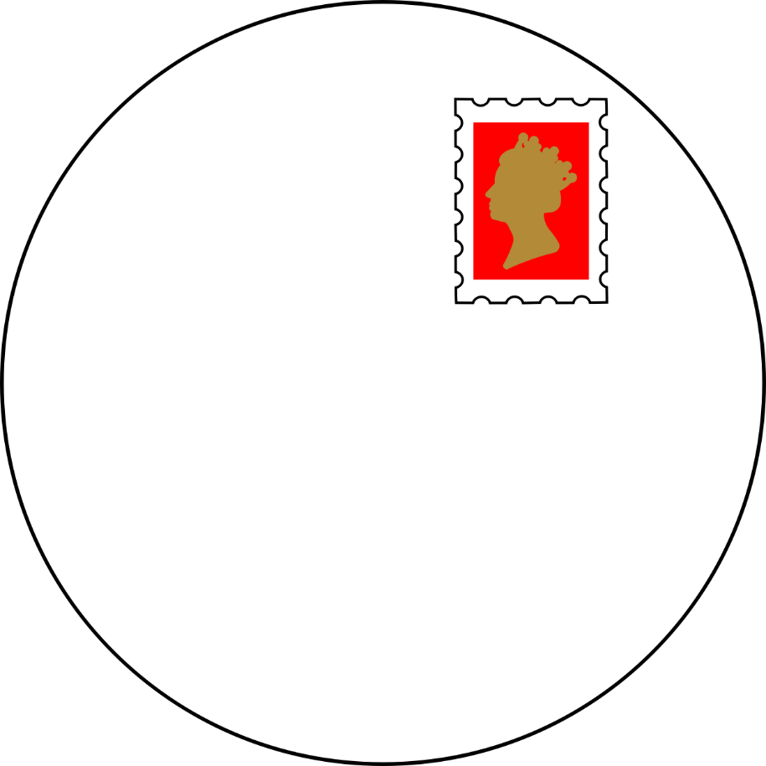
I’m a text box to enable you to input your own address

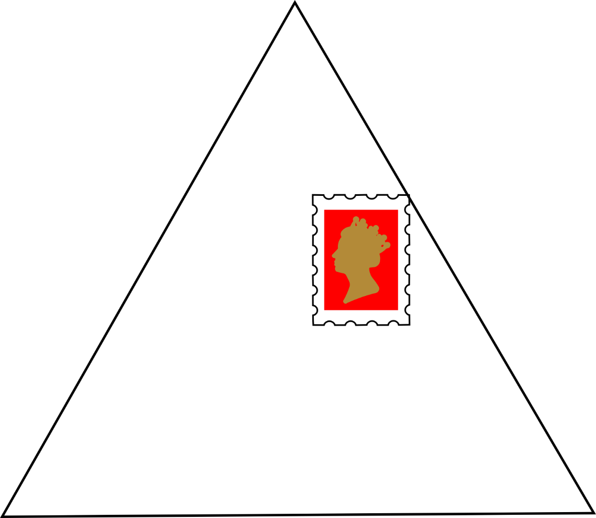
I’m a text box to enable you to input your own address

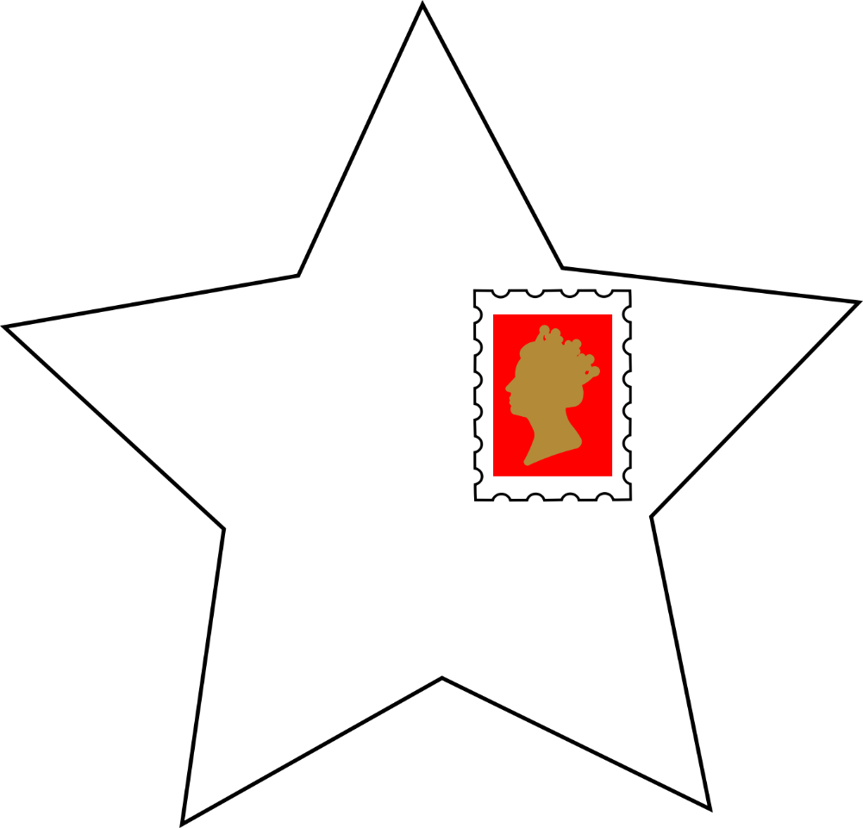

I’m a text box to enable you to input your own address

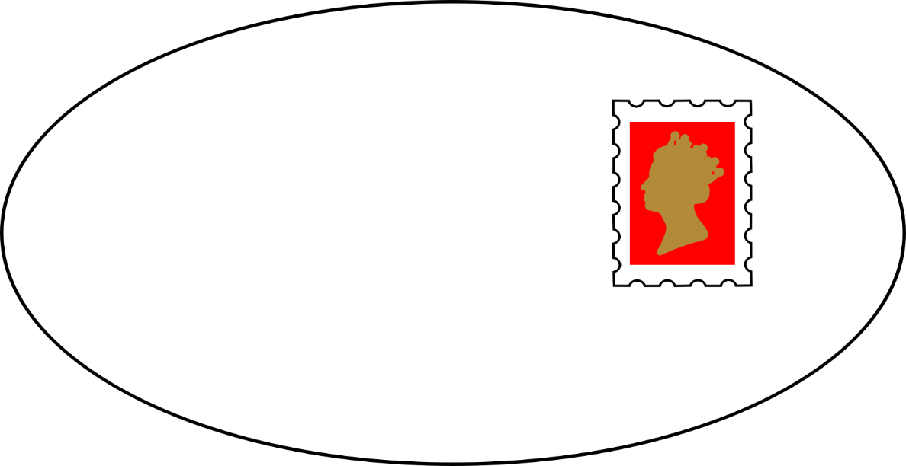
I’m a text box to enable you to input your own address



