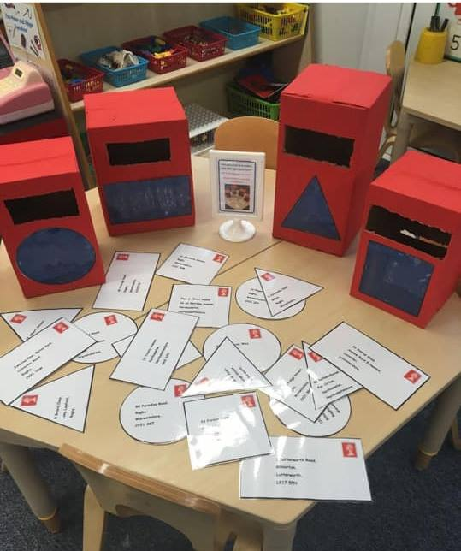

Postbox letter shape sorting

Please note, we did not develop the original idea of this, but have been inspired by a Pinterest pin



I’m a text box to enable you to input your own address

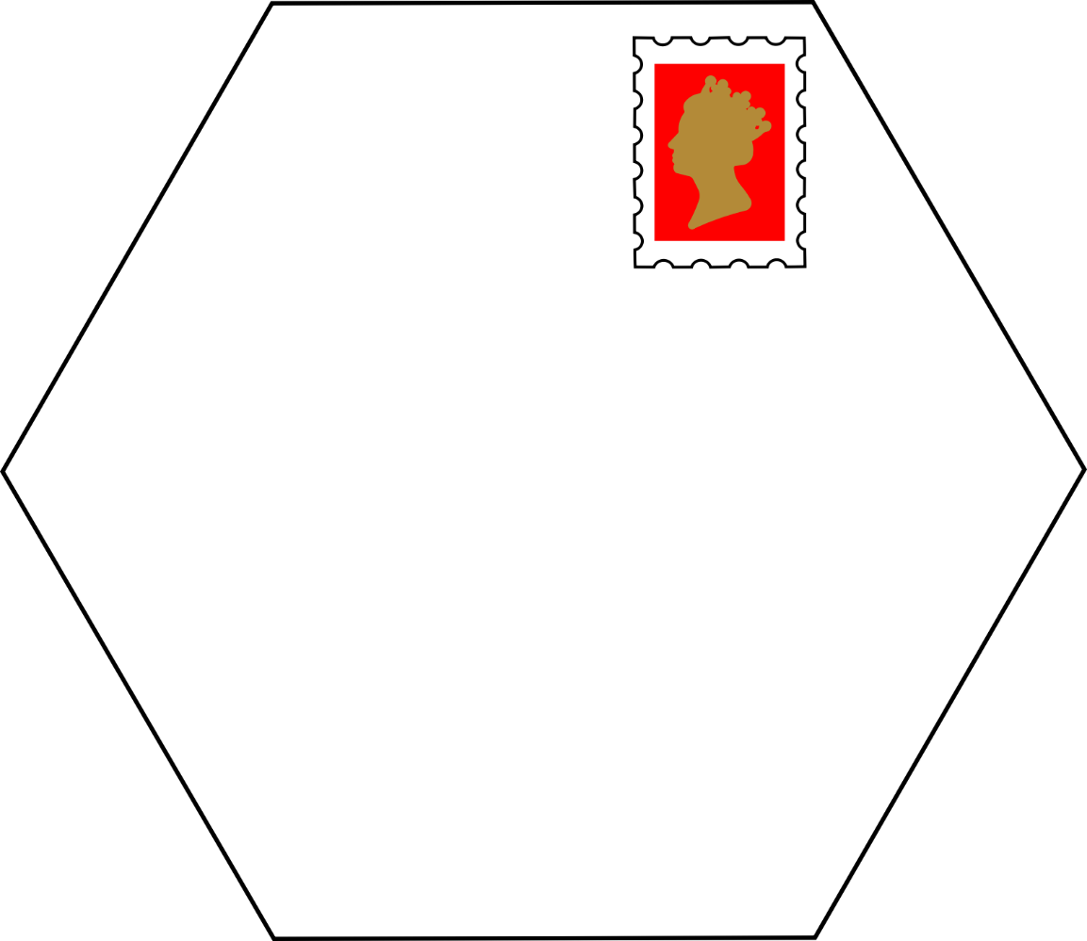

I’m a text box to enable you to input your own address

 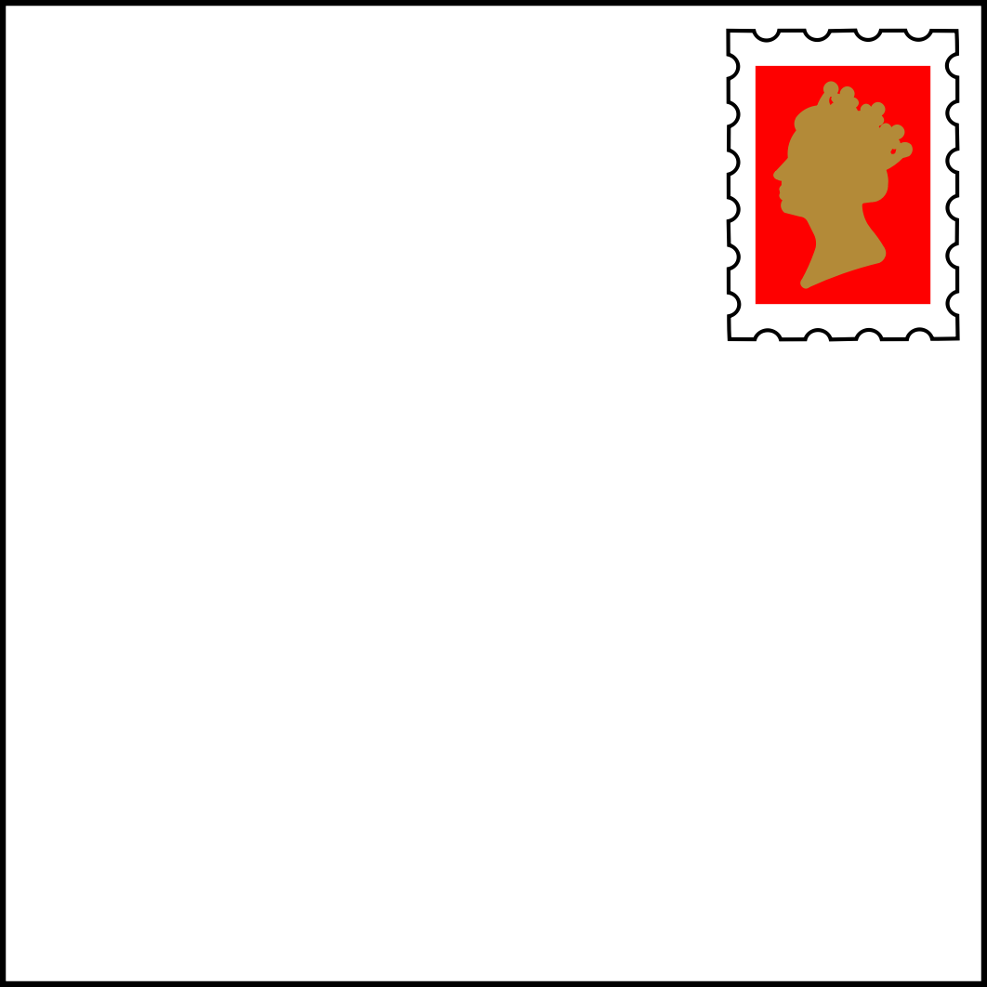

I’m a text box to enable you to input your own address

I’m a text box to enable you to input your own address

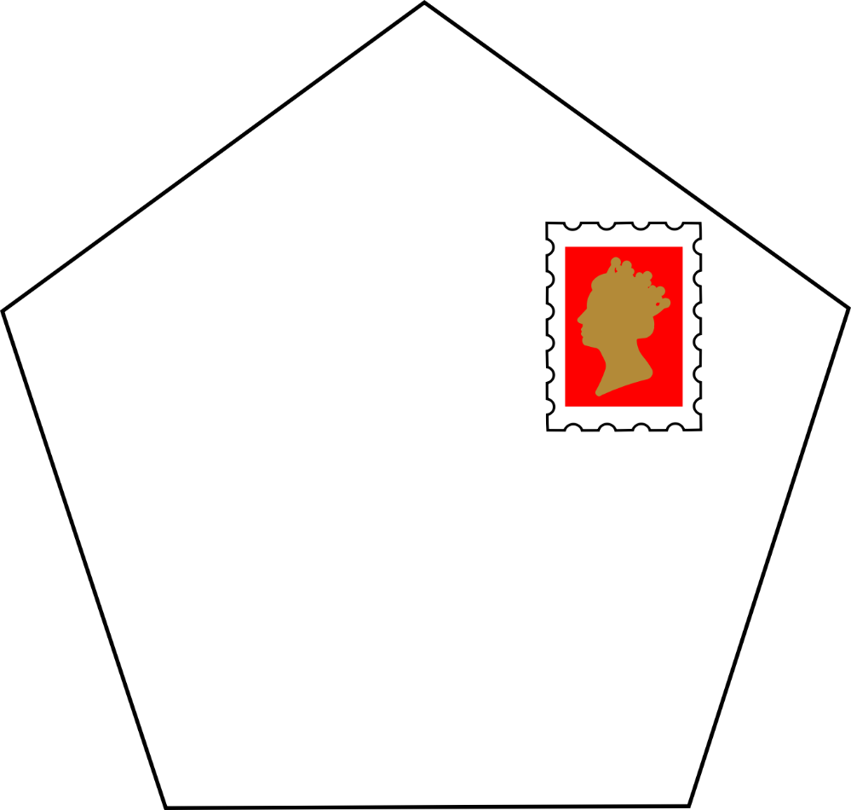

I’m a text box to enable you to input your own address

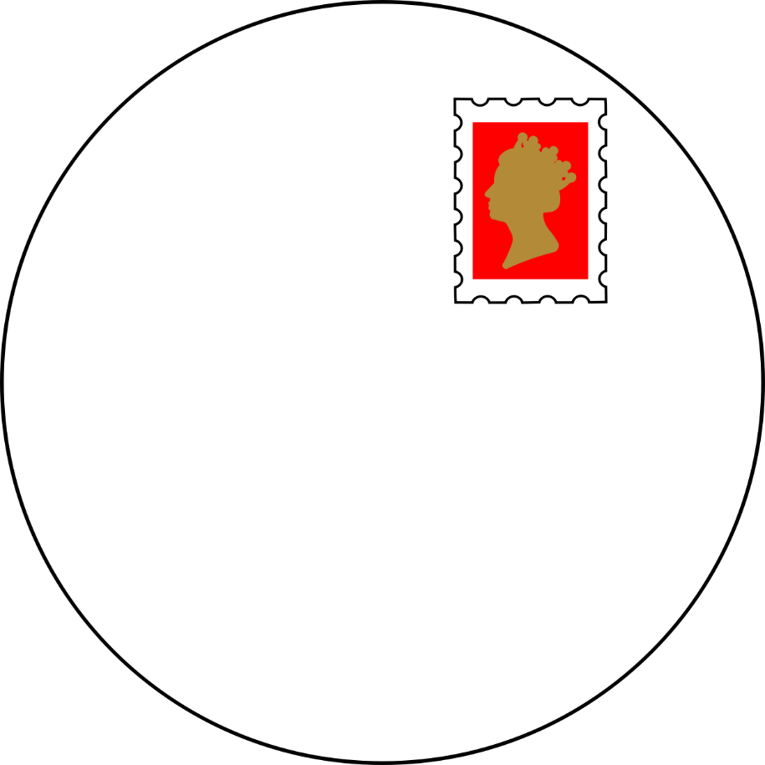

I’m a text box to enable you to input your own address

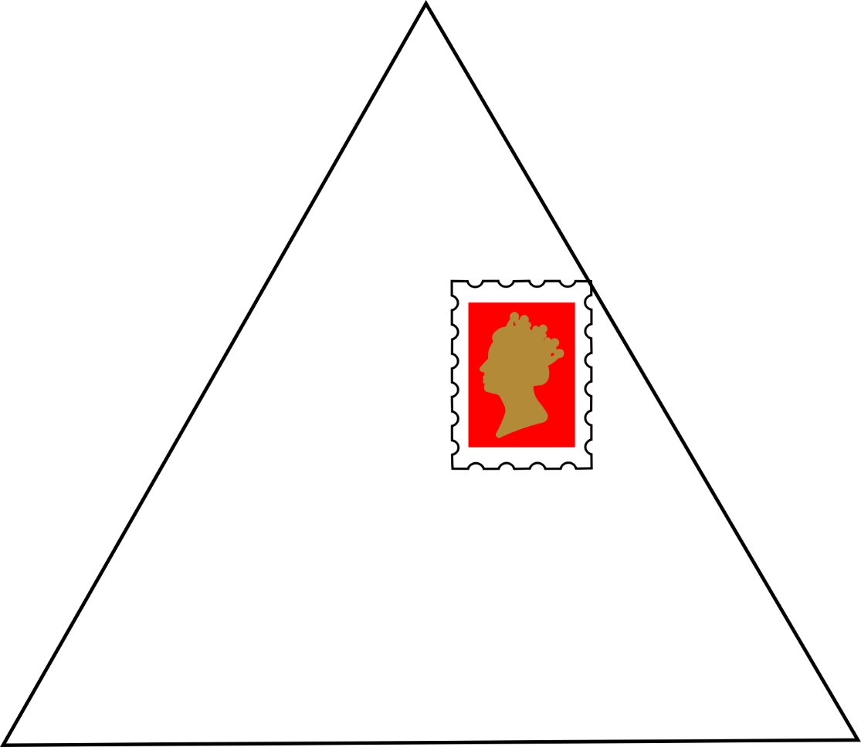

I’m a text box to enable you to input your own address

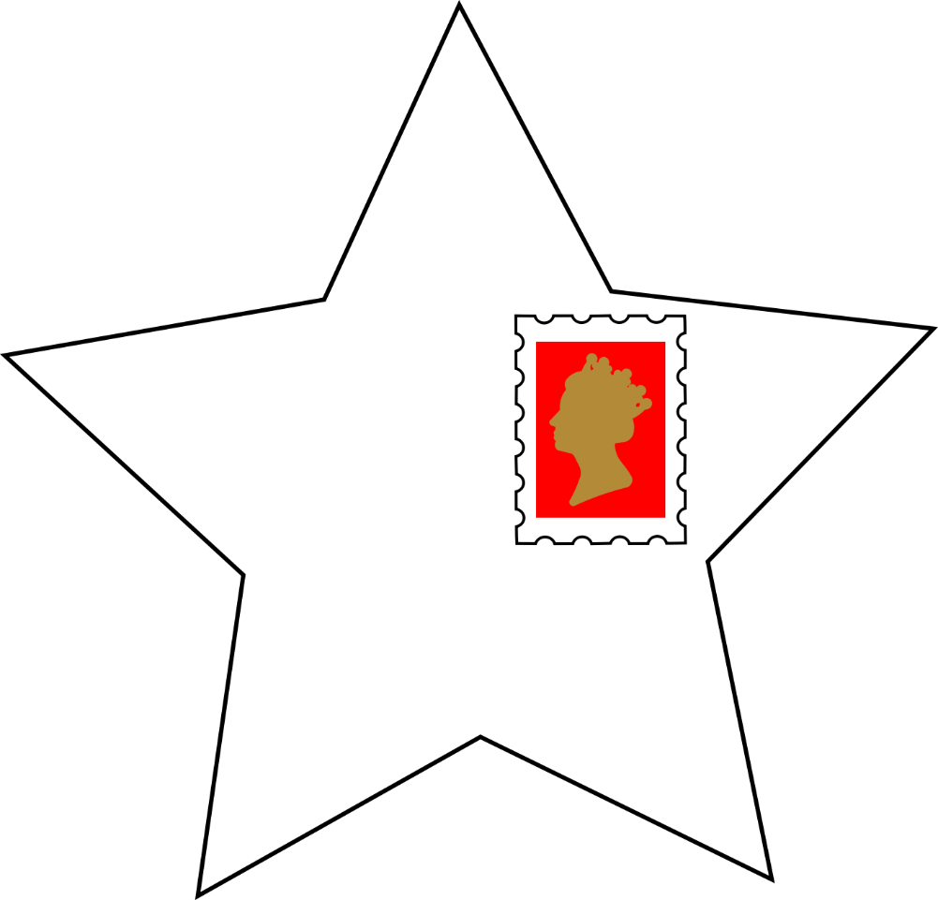

I’m a text box to enable you to input your own address

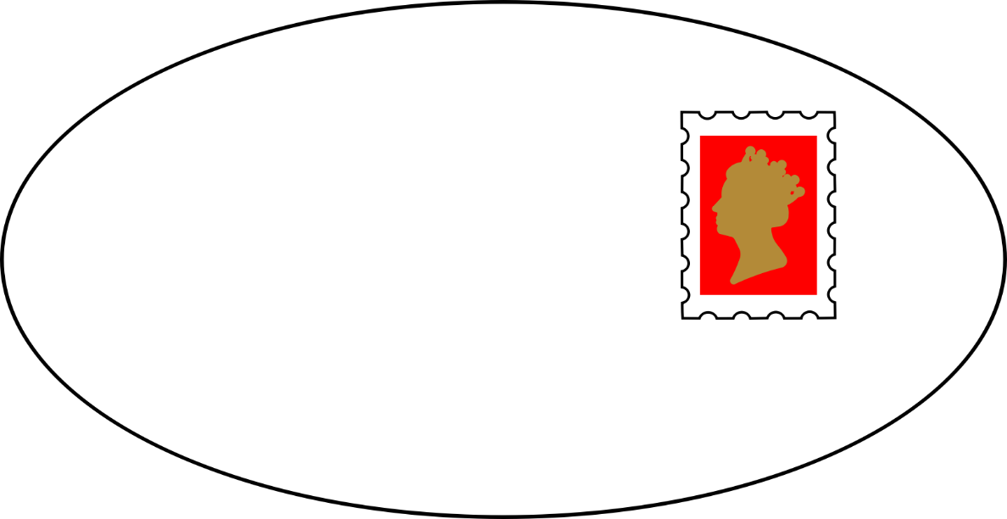

I’m a text box to enable you to input your own address

